**Chapter 1**

**INTRODUCTION**

This chapter provides a comprehensive introduction to the project, "Eventra: A College Event Management System." It outlines the fundamental need for such a system within a campus environment, specifies the problems it aims to solve, and details the tasks required for its successful implementation. Furthermore, a projected timeline is presented, followed by an overview of this report's organizational structure.

**1.1: Need Identification**

The modern campus life is a hectic one where students are busy with lectures, assignments, and other academic obligations that they are not given time to keep abreast with the happenings around them both in extracurricular and co-curricular matters. Colleges have so many activities on a daily basis such as cultural fests, seminars, sports competitions, workshops among others, yet due to the absence of a centralized system of notifying students, they are missing all these events. Conventional strategies such as posters, notice boards and word of mouth announcements are not effective and they may not reach all the students at the right time. Besides, students have no convenient method of tracking their attendance or participation online. This presents an apparent necessity of a digital platform that may serve as a one-stop destination in terms of discovering events, enrolling into them and tracking attendance. Eventra is created to satisfy this requirement. It offers a real time and user-friendly web portal through which students can access all available on events happening at the campus, they can join the events at ease or they can just book an E-ticket in case they would just be spectators. With this system, all the events will not pass unnoticed and all students will be equally able to get information on what is going on in the campus.

In any vibrant academic institution, the holistic development of students extends beyond the classroom. Extracurricular and co-curricular activities are crucial for fostering community, building skills, and enhancing the overall student experience. There exists a fundamental **need for a centralized and efficient system** that can effectively connect students with the rich tapestry of opportunities available on campus. Students need a reliable, single point of access to stay informed, while event organizers need an effective channel to promote their activities and maximize participation. The core need is to transform a fragmented and often chaotic event landscape into a streamlined, accessible, and engaging ecosystem that benefits the entire college community. This project, Eventra, is born from the need to bridge this gap and unlock the full potential of campus life.

**1.2: Identification of Problem**

The core problem observed within the dynamic college environment is the profound **lack of a unified, streamlined system for event management** and student engagement. A university campus is a bustling ecosystem of academic, cultural, technical, and social events. However, despite the high volume and variety of activities organized, the communication channels between event organizers and the student body remain critically fragmented and inefficient. This creates a significant **communication chasm**, where valuable opportunities are planned and executed but fail to reach their intended audience effectively.

For students, this informational disconnect leads to a pervasive sense of **"fear of missing out" (FOMO)**. They often learn about valuable workshops, insightful guest lectures, or vibrant cultural festivals only after they have concluded, leading to disappointment and a feeling of being disconnected from the pulse of the campus. This results not only in poor participation rates but also in missed opportunities for skill development, networking, and personal growth. The overall consequence is an erosion of the campus community, as shared experiences—the very fabric of college life—become limited to a small, well-informed fraction of the student population.

From the perspective of event organizers, the challenges are equally daunting. They invest considerable time and effort in planning and execution but face immense difficulty in promoting their events effectively. They are forced to post announcements across a dozen different platforms—departmental websites, multiple social media groups, and physical notice boards—with no guarantee of reaching their target audience. This "shout into the void" approach is inefficient and often yields a low return on effort. Furthermore, they are burdened with **manual and archaic methods for managing participation**. Paper-based registration forms, long queues for on-the-spot sign-ups, and manual entry verification are not only time-consuming and unprofessional but are also highly prone to human error. Critically, these methods leave **no reliable digital record** of attendance or participation. This absence of data makes it impossible to analyze engagement trends, understand event popularity, or efficiently issue certificates of participation, leaving future event planning to guesswork rather than data-informed strategy.

Therefore, the identified problem can be summarized as the absence of a centralized event management ecosystem that provides **real-time updates, facilitates seamless participation, and automates tracking and entry management**. Eventra is designed to directly address these multifaceted issues by creating a single, structured, and reliable platform that benefits the entire campus community.

The need for a superior system is underscored by several specific, recurring problems:

* **Information Fragmentation:** Event details are not just scattered; they exist in isolated **informational silos**. A student might have to check the engineering department’s website for a technical seminar, the drama club’s Instagram page for a play, a departmental WhatsApp group for a workshop, and a physical flyer in the library for a book fair. This decentralization forces students into a frustrating "digital scavenger hunt" to stay informed, a task so demanding that most simply give up.
* **Lack of Real-Time Updates:** Traditional communication methods are fundamentally static and cannot keep pace with the dynamic nature of events. A last-minute venue change, a delay in start time, or an outright cancellation is often communicated through a single channel, leaving many attendees misinformed. This leads to wasted time and significant frustration, for example, when a student travels across campus for a workshop only to find it was canceled via a message in a social media group they are not a part of.
* **Ineffective Reach and Digital Noise:** In the current digital landscape, mere announcement is not enough. Organizers compete with a deluge of other content on social media, where algorithms may suppress their posts, preventing them from even appearing on their followers' feeds. Important information is frequently lost in this **digital noise**, resulting in alarmingly low visibility and, consequently, poor attendance.
* **Passive Information Flow:** The existing model places the entire burden of discovery on the student. It is a **"pull-based" system** where students must actively and continuously pull information from numerous sources. There is no proactive, "push-based" system to notify students of relevant opportunities based on their interests. This cognitive overload is a significant barrier to participation.
* **Tedious Registration and Logistical Tracking:** The process of participation is often clunky and inefficient. Online forms are disconnected from a central system, and on-site registration leads to bottlenecks and long queues at the event entrance. For organizers, manually transcribing names from illegible sign-up sheets to create attendance records is a logistical nightmare that is both inefficient and susceptible to errors. This lack of a streamlined process detracts from the professionalism of the event and creates a poor experience for attendees from the very start.

**1.3 Identification of Tasks**

To successfully conceptualize, develop, and implement the Eventra system, the project was strategically broken down into a series of key tasks and milestones. This modular approach ensured a systematic and well-organized workflow, allowing for focused development on each component of the application before integration. Each task represents a critical stage in the project's lifecycle, from initial planning to final deployment and evaluation.

**1. Requirement Analysis**

This foundational stage was dedicated to understanding the core problems and defining the precise scope of the solution. It involved a deep dive into the needs of the primary stakeholders—**students** and **event organizers**. The process included:

* **Stakeholder Needs Assessment:** Conducting an analysis of the challenges faced by students (e.g., missing events) and organizers (e.g., poor reach, manual tracking).
* **Defining Functional and Non-Functional Requirements:** This involved creating a clear list of what the system must *do* (functional requirements), such as user login, event listing, and E-ticket generation. It also involved defining how the system must *be* (non-functional requirements), such as ensuring the website is responsive, secure, and provides a fast-loading, intuitive user experience.

**2. System Design**

This phase served as the architectural blueprinting stage, where the theoretical requirements were translated into a concrete technical design. It was crucial for building a scalable and maintainable application.

* **Database Schema Design:** This involved creating a detailed **Entity-Relationship Diagram (ERD)** to model the structure of the database. It included defining the tables (users, events, registrations), specifying their attributes (e.g., data types, constraints), and establishing primary and foreign key relationships to ensure **data integrity and normalization**.
* **UI/UX Design:** The focus was on designing the user's journey. This began with creating **low-fidelity wireframes** to map out the basic layout, component placement, and navigation flow. This was followed by developing **high-fidelity mockups** to define the visual identity of Eventra, including its color palette, typography, and overall aesthetic, ensuring the final design would be both user-friendly and visually engaging.

**3. Front-End Development**

This task involved bringing the visual designs to life, creating the client-side of the application that users directly interact with. The primary goal was to build a seamless, responsive, and interactive user interface.

* **Structural Development with HTML:** Building the semantic structure of all web pages.
* **Styling with CSS:** Applying the visual design using CSS to style components, manage layouts (using modern techniques like Flexbox and Grid), and ensure the application is fully responsive across devices, from desktops to mobile phones.
* **Interactivity with JavaScript:** Implementing client-side JavaScript to handle user interactions, validate forms in real-time for a better user experience, and make asynchronous requests to the back-end where necessary.

**4. Back-End Development**

Often called the "engine room" of the application, this stage involved building the server-side logic that powers Eventra's functionality. This is where all the data processing and core operations happen.

* **Server-Side Logic with PHP:** Writing robust PHP scripts to handle all core functionalities. This included managing secure user **authentication** (registration, login, and session management), processing all incoming data from front-end forms, and implementing the business logic for creating, updating, and displaying events. **Security was paramount**, involving practices like hashing passwords and sanitizing user inputs to prevent vulnerabilities like SQL injection and XSS.
* **Database Interaction with SQL:** Establishing a secure connection to the MySQL database and writing optimized SQL queries to perform all **CRUD (Create, Read, Update, Delete)** operations. This ensured that data could be stored, retrieved, and managed efficiently and reliably.

**5. Integration and Testing**

This critical phase focused on ensuring all parts of the application work together as a cohesive unit. It is the primary quality assurance stage.

* **Module Integration:** Connecting the front-end user interface with the back-end logic. This involved ensuring that user actions on the website (like clicking a "Register" button) correctly trigger the appropriate PHP scripts, which in turn process the request, interact with the database, and return the correct response to the user.
* **Comprehensive Testing:** Executing a multi-level testing strategy to identify and eliminate bugs. This included **integration testing** to verify that connected modules work together correctly and **end-to-end system testing** to validate complete user workflows, such as registering a new account, logging in, and successfully enrolling in an event.

**6. Deployment and Evaluation**

The final stage involved launching the application and evaluating its real-world effectiveness.

* **Deployment:** Migrating the entire application from the local development environment to a live or college-hosted server. This process included configuring the server environment, uploading all project files, and importing the database schema and data, making Eventra accessible to its intended users.
* **Evaluation:** Assessing the project's success against the objectives defined in the initial analysis phase. This involved measuring system performance, conducting **usability testing** by observing users interacting with the platform, and gathering direct feedback to gauge user satisfaction and identify potential areas for future improvements.

**1.4 Timeline**

The development of the Eventra project was executed over a structured four-week period. The project was divided into four distinct phases, with each phase spanning one week and focusing on a specific set of milestones. This phased approach ensured a logical progression from planning and design to development, testing, and final deployment.

* **Phase 1: Foundation and Blueprinting (Week 1)** The initial week was dedicated entirely to establishing a solid foundation for the project. The first critical task was **Requirement Gathering and Analysis**, which involved a deep dive into the needs of the end-users to define the core functionalities of the application. Immediately following this, the insights gained were used for the **System and Database Design**. During this stage, the complete architectural blueprint for Eventra was created, including the essential Entity-Relationship Diagrams (ERDs) for the database and the high-level design for the application's structure.
* **Phase 2: Core Development (Week 2)** The second week marked the beginning of active development, with a parallel focus on both the front-end and back-end. The **Front-End Development** task concentrated on building the initial user-facing components: the visually engaging landing page and the secure login/registration pages. Concurrently, the **Back-End Development** involved setting up the server environment, implementing the database schema designed in the previous phase, and writing the initial PHP scripts for handling user authentication and establishing a reliable connection to the SQL database.
* **Phase 3: Feature Implementation and Refinement (Week 3)** During the third week, the project's core features were developed and integrated. The primary task was the **Dashboard Creation and Ticket System Implementation**, which involved building the interactive student dashboard where events are displayed and implementing the back-end logic for event registration and the automatic generation of E-tickets. Alongside this intensive development, this phase also included continuous **Testing, Debugging, and Refinement**. As new features were built, they were rigorously tested to identify and fix bugs, ensuring the application remained stable and functional.
* **Phase 4: Finalization and Documentation (Week 4)** The final week of the project was focused on preparing the application for its launch and completing all associated documentation. The main task was the **Final Deployment**, where the fully tested and functional web application was moved from a local development environment to a live server. In parallel, a significant effort was dedicated to finalizing the **Project Documentation**. This involved completing this comprehensive report, ensuring that all aspects of the project, from the initial requirements to the final evaluation, were thoroughly documented for future reference and review.

**1.5 Organization of the Report**

This project report is systematically organized into five distinct chapters to present the development lifecycle of the **Eventra** platform in a structured, logical, and comprehensive manner. Each chapter builds upon the last, guiding the reader through the project's entire journey—from the initial conceptualization and problem analysis to the final implementation, rigorous evaluation, and future potential.

**Chapter 1: Introduction**

This initial chapter serves as the foundation for the entire report. It **sets the stage** by establishing the context and motivation behind the Eventra project. It begins by identifying the critical need for a centralized event management system within the college environment and provides a detailed analysis of the problems faced by both students and event organizers. This section formally defines the project's specific, measurable goals and objectives. Finally, it concludes by presenting this very roadmap, outlining the structure and organization of the subsequent chapters to the reader.

**Chapter 2: System Analysis and Design**

This chapter acts as the **architectural blueprint** of the project. It delves into a thorough analysis of the existing systems (or lack thereof), justifying the technical and functional requirements of the proposed solution. This section details the high-level system architecture, illustrating the relationship between the front-end, back-end, and database. It provides visual models for clarity, including **Data Flow Diagrams (DFDs)** to map the journey of information through the system and **Entity-Relationship (ER) models** that define the database schema, its tables, and the relationships crucial for maintaining data integrity.

**Chapter 3: System Implementation**

In this chapter, the theoretical blueprint from the previous section is transformed into a tangible, functional application. It serves as a bridge between design and execution. The chapter begins with a detailed discussion of the chosen **technology stack** (HTML, CSS, JavaScript, PHP, SQL) and justifies these choices. It then breaks down the development process into the implementation of key modules, including the secure **User Authentication system**, the administrative **Event Management panel**, the dynamic **Student Dashboard**, and the automated **E-Ticket Generation** feature.

**Chapter 4: System Testing and Evaluation**

This chapter is dedicated to **quality assurance**, detailing the rigorous processes undertaken to verify that the Eventra system is robust, reliable, and performs as expected. It outlines the multi-layered testing strategy, covering different methodologies used to identify and resolve bugs. This section presents a series of detailed **test cases**, which document specific scenarios, user actions, expected outcomes, and the actual results. The chapter concludes by evaluating these results to validate that the system successfully meets all the functional requirements and objectives defined at the project's outset.

**Chapter 5: Conclusion and Future Scope**

The final chapter provides a conclusive summary and a forward-looking perspective on the project. It begins by reiterating the project's achievements and how the Eventra platform successfully addresses the initial problem statement. It also includes a critical self-assessment of the project's current **limitations**. Finally, this chapter looks to the future, proposing a roadmap for potential enhancements and new features—such as dedicated organizer dashboards, a notification system, or calendar integration—that could be implemented to further expand Eventra's capabilities and impact.

**Chapter 2**

**BACKGROUND STUDY**

This chapter explores the context surrounding the Eventra project. It begins by tracing the history of the problem, presents the proposed solution, and reviews existing systems to identify a gap in the current landscape. Finally, it provides a formal problem definition, outlines the project's primary objectives, and justifies the selection of the technology stack.

**2.1 Timeline of the Reported Problem**

Over the years, educational institutions have significantly expanded their focus on co-curricular and extracurricular activities, organizing events to enhance students’ creativity, leadership, and collaboration skills. However, as the number of events increased, the methods of communication and participation management failed to keep pace.

Initially, event details were shared through physical posters, notice boards, and department announcements, which had limited reach and were time-consuming to update. As digital communication grew, student groups began using WhatsApp, emails, and social media for event promotion. Although these platforms helped spread awareness, they lacked proper organization, verification, and real-time updates. Students often missed messages, found outdated information, or received duplicate notifications across multiple groups.

By 2024, as campus activities became more frequent and dynamic, the absence of a centralized event management portal became a recurring issue. Event organizers struggled with maintaining records, while students complained about missing events even when they were happening right on the campus grounds. This persistent communication gap formed the foundation for the Eventra project — an initiative to digitalize and centralize all campus event updates in one accessible system.

**2.2 Proposed Solution**

To resolve these challenges, the Eventra platform is proposed as a unified, web-based event management system that connects students and event organizers in real time.

The proposed solution focuses on:

* Centralization: Creating a single portal where all campus events are listed and updated regularly.
* Accessibility: Allowing students to view ongoing and upcoming events through a user-friendly dashboard.
* Digital Participation: Enabling students to enroll online as participants or generate E-tickets as spectators.
* Transparency: Allowing event organizers to upload accurate event details accessible to all students.
* Efficiency: Eliminating the dependency on manual announcements or fragmented communication channels.

By using HTML, CSS, JavaScript, PHP, and SQL, Eventra ensures an efficient, interactive, and database-driven experience. The platform supports real-time event discovery, secure login mechanisms, and automatic ticket generation — all designed to make campus engagement easier, faster, and smarter.

**2.3 Bibliometric Analysis**

A bibliometric study of similar event management and information dissemination systems reveals that web-based and mobile-based platforms have been widely used across educational and organizational contexts. Several research papers highlight the importance of centralized platforms for improving user engagement and communication.

According to studies on event management systems:

* Systems built with PHP and MySQL are the most common for campus-based portals due to their open-source nature and ease of database handling.
* Platforms that integrate real-time updates (through AJAX or JavaScript) significantly increase user interaction compared to static websites.
* Research also shows that responsive designs (HTML5 and CSS3) contribute to higher adoption rates among students who access portals from mobile devices.
* In user experience studies, systems with automated ticketing or confirmation mechanisms achieved higher satisfaction levels due to reduced manual intervention.

These findings support the design approach adopted for Eventra. By integrating commonly used, well-supported technologies, the system ensures scalability, accessibility, and reliability while maintaining low deployment costs — crucial for institutional adoption.

**2.4 Review Summary**

The literature and system reviews indicate that although various event management tools exist, most are commercial, subscription-based, or designed for large-scale professional events. They are often too complex for a college setting or require technical expertise to manage.

In contrast, campus environments need a simpler, focused system — one that provides essential features like event listing, registration, and attendance tracking without unnecessary overhead. Eventra addresses this exact requirement by combining simplicity with functionality.

Key takeaways from prior studies and observations include:

* A need for real-time event updates accessible to all students.
* The advantage of digital E-ticketing over manual registration.
* Importance of lightweight, open-source technologies for deployment.
* A growing preference for web-based over mobile-only platforms due to cross-device compatibility.

This review validates that the Eventra system aligns perfectly with the unique needs of a university environment and fills a long-standing communication and management gap.

**2.5 Problem Definition**

Despite the increasing use of digital tools, students in colleges continue to miss events happening on campus due to scattered or delayed communication. Event organizers lack a structured way to promote their events, while students lack a centralized source of truth.

The core problem can be defined as:

“The absence of a centralized, real-time event management platform within the college environment results in communication gaps, low participation rates, and lack of accessibility for students to discover and register for ongoing or upcoming events.”

This problem affects both students (due to unawareness and missed opportunities) and organizers (due to inefficient promotion and tracking).

**2.6 Goals and Objectives**

The primary goal of Eventra is to bridge the communication gap between students and organizers by creating a digital ecosystem that promotes engagement, transparency, and convenience.

**Objectives**:

1. To design and develop a user-friendly web application for campus event discovery.
2. To enable real-time posting and updating of event details by authorized users.
3. To allow students to enroll for participation or generate digital E-tickets for attendance.
4. To create a structured database for storing event, user, and ticket data efficiently.
5. To reduce dependency on physical promotions and manual registration systems.
6. To ensure platform responsiveness and compatibility across different devices.
7. To implement a secure login system for user authentication and data protection.

By achieving these objectives, Eventra aims to modernize event management and enhance the student experience within the campus environment.

**2.7 Why Use These Technologies Over Others**

The selection of HTML, CSS, JavaScript, PHP, and SQL for this project is driven by the need for simplicity, cost-effectiveness, and reliability. Each technology was carefully chosen based on its strengths and suitability for academic web applications.

|  |  |  |
| --- | --- | --- |
| **Technology** | **Purpose** | **Reason for Choice** |
| **HTML (Hypertext Markup Language)** | Structure and layout of the web pages. | Universally supported, lightweight, and perfect for static page content creation. |
| **CSS (Cascading Style Sheets)** | Styling and visual design. | Enables responsive, visually appealing, and consistent UI across all devices. |
| **JavaScript** | Client-side interactivity. | Adds dynamic features like event updates, form validation, and real-time interactions. |
| **PHP (Hypertext Preprocessor)** | Server-side scripting and backend logic. | Well-suited for handling sessions, authentication, and database connections efficiently. |
| **SQL (Structured Query Language)** | Database management. | Provides reliable and structured data storage, easy querying, and secure data retrieval. |

**Chapter 3**

**DESIGN AND PROCESS**

**3.1 Evaluation & Selection of Specifications / Features**

Before initiating the design phase of **Eventra**, a detailed analysis was conducted to determine which features would best serve the needs of both students and event organizers. The goal was to create a web application that is simple to use, fast to access, and visually appealing while maintaining functionality and scalability.

After evaluating multiple use cases, feedback from students, and studying similar event-based systems, the following key **specifications and features** were finalized for inclusion:

**Core Specifications**

* **Platform Type:** Web-based application.
* **User Types:** Students, Organizers, and Admin (optional future role).
* **Database:** MySQL for storing user and event data.
* **Authentication:** PHP-based login and session management system.
* **Responsive Design:** Mobile and desktop compatible using HTML5 and CSS3.
* **Dynamic Interactions:** JavaScript for form validations and event filtering.

**Main Features**

1. **Event Discovery:**  
   Students can view all ongoing and upcoming campus events with detailed descriptions.
2. **Event Enrollment:**  
   Allows users to register for participation or attendance in events.
3. **E-Ticket Generation:**  
   Automatically generates a digital ticket with event name, date, and QR code or ID for attendees.
4. **Organizer Upload Portal:**  
   Enables authorized users to post or edit event details.
5. **User Dashboard:**  
   Personalized space showing user-specific registered events and generated tickets.
6. **Notifications:**  
   Visual indicators or updates for newly posted or soon-to-start events.

These features were selected to ensure Eventra is practical, engaging, and addresses the real issues faced on campus.

**3.2 Design Constraints**

During the design and development of **Eventra**, several **constraints** were identified that influenced technical and functional decisions. These constraints guided the development process to ensure feasibility and maintain efficiency.

**a) Technical Constraints**

* **Limited Hosting Resources:**  
  Since the project is designed for institutional use, the system must run smoothly on local or college-hosted servers without heavy resource demands.
* **Browser Compatibility:**  
  The design must work across major browsers like Chrome, Edge, and Firefox without requiring plugins.
* **Limited Budget:**  
  The project uses only open-source tools and technologies, avoiding paid APIs or commercial frameworks.

**b) Design Constraints**

* **Simplicity of UI:**  
  The interface must remain simple enough for first-time users to navigate without training.
* **Consistency:**  
  The design follows a uniform theme and color palette representing the campus environment.
* **Scalability:**  
  The database design should accommodate more events and users as adoption increases.
* **Data Privacy:**  
  User credentials and event information must be securely stored, with restricted data access.

**c) Human Constraints**

* **Limited Team Size:**  
  Development was carried out by a small student team, so implementation had to remain achievable within a short time.
* **Time Constraints:**  
  The complete system was developed within a limited academic semester, requiring an optimized workflow.

These constraints were treated as design boundaries that shaped the overall look, feel, and technical execution of the project.

**3.3 Design Flow**

The **design flow** of Eventra follows a structured, modular approach to ensure clarity and maintainability during development. The workflow moves from understanding user needs to designing interfaces, developing back-end logic, and finally integrating both sides for seamless performance.

**Design Flow Steps:**

1. **Requirement Analysis:**  
   Identifying user needs and system requirements through observation and discussion.
2. **System Architecture Planning:**  
   Defining how the front-end, back-end, and database interact.
3. **Interface Wireframing:**  
   Creating rough sketches and layouts for the landing page, login page, and dashboard.
4. **Database Schema Design:**  
   Structuring tables for users, events, and tickets using SQL.
5. **Front-End Development:**  
   Implementing layouts and styles using HTML, CSS, and JavaScript.
6. **Back-End Development:**  
   Developing PHP scripts for login, event posting, and ticket generation.
7. **Integration and Testing:**  
   Connecting front-end with back-end and verifying data flow.
8. **Final Evaluation and Deployment:**  
   Testing the platform’s performance and launching it for institutional use.

The modular flow ensures that each stage could be developed independently and later integrated without conflicts, resulting in a clean and scalable codebase.

**3.4 Creation of “Eventra”**

The name **“Eventra”** was derived from two words: *Event* and *Era*. Together, they symbolize *“the new era of event discovery”* — a modern solution for campus activity management.

The concept was born from real-life observations within the college environment, where students frequently missed campus happenings. The goal was to create a **portal that turns campus events into a connected ecosystem** accessible to everyone in real time.

The development process began with:

* Designing a **modern landing page** to introduce Eventra’s purpose.
* Implementing a **secure login system** to personalize the student experience.
* Building the **Student Dashboard**, the core area where users view, register, and manage their events.

Throughout its creation, emphasis was placed on **simplicity, responsiveness, and clarity**, ensuring that Eventra feels both professional and intuitive to users.

**3.5 Logo Designing and Naming**

A strong project identity starts with effective branding. The **Eventra logo** was designed to reflect energy, connectivity, and enthusiasm — the essence of campus life.

**Logo Design Process:**

1. **Concept Ideation:**  
   The logo needed to capture the essence of college events — fun, engagement, and technology.
2. **Design Elements:**  
   The logo includes an icon resembling a *location pin* merged with a *spark* or *flare*, representing activity happening in a specific spot on campus.
3. **Color Scheme:**  
   Blue and orange tones were chosen:
   * **Blue:** Symbolizes reliability and technology.
   * **Orange:** Represents energy, excitement, and youthfulness.
4. **Typography:**  
   The word *Eventra* is styled in a modern sans-serif font to ensure readability and simplicity.

The final design delivers a recognizable, energetic, and minimalistic identity that aligns perfectly with the platform’s purpose.

**3.6 Implementation Plan / Methodology**

The **implementation methodology** for Eventra followed an **iterative development model**, ensuring that each phase was tested, reviewed, and refined before moving to the next.

**Stage 1: Planning and Requirement Analysis**

* Collected functional and non-functional requirements from student and faculty feedback.
* Finalized features such as event viewing, registration, and E-ticket generation.

**Stage 2: System Design**

* Created the database structure (users, events, tickets).
* Designed the front-end layout using wireframes and prototypes.

**Stage 3: Development**

* Implemented the landing page and login system.
* Developed backend scripts in PHP for data handling and authentication.
* Integrated event upload and ticket generation modules.

**Stage 4: Testing**

* Conducted unit testing for each module.
* Performed integration testing to ensure data consistency between front-end and database.

**Stage 5: Deployment**

* Deployed the system on a local server for demonstration.
* Conducted real-user testing within the campus.

**Stage 6: Maintenance and Evaluation**

* Fixed post-deployment bugs and improved performance.
* Collected feedback for potential future improvements like push notifications and mobile app expansion.

The iterative approach ensured that every module of Eventra was functional, user-friendly, and aligned with the project’s overall objectives.

**3.7 Database Design and ER Diagram**

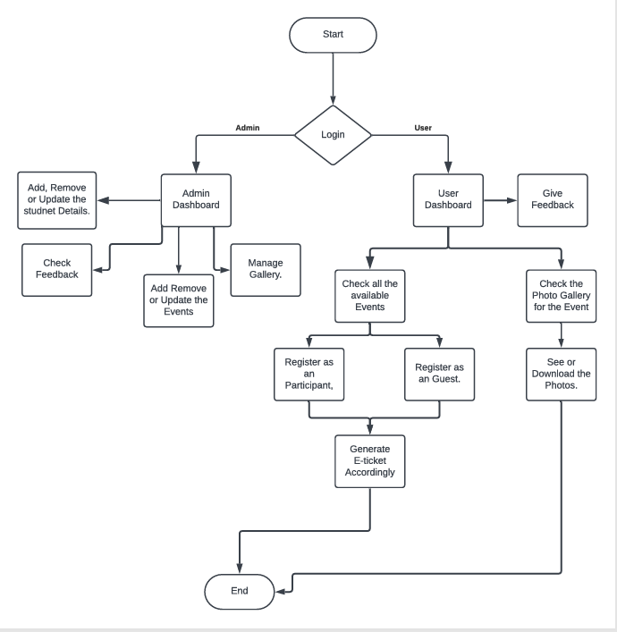**Flow Chart**

**Database Schema (College_event_system)**

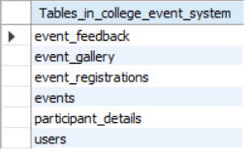**List of Tables:**

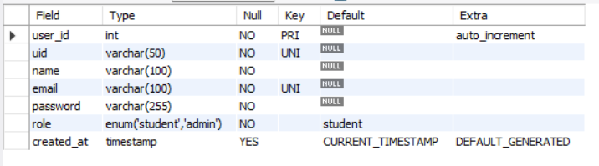 **User Table**

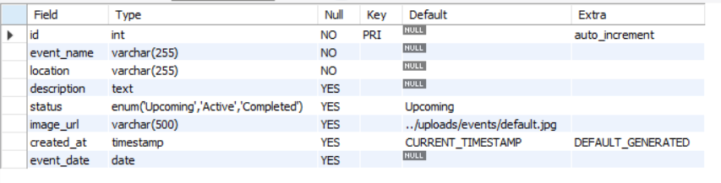**Event Table**

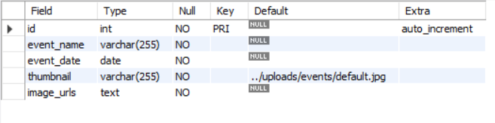**Event Gallery Table**

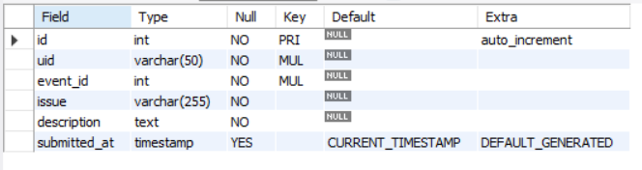**Event Feedback Table**

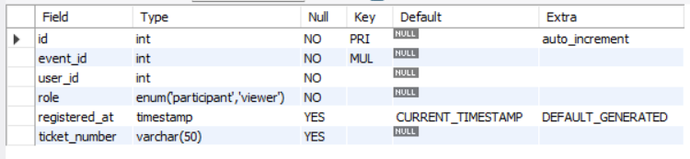 **Event Registration Table**

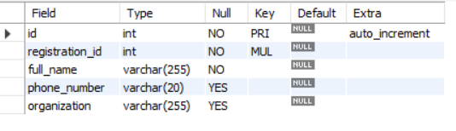 **Participant Details Table**

**ER Diagram**

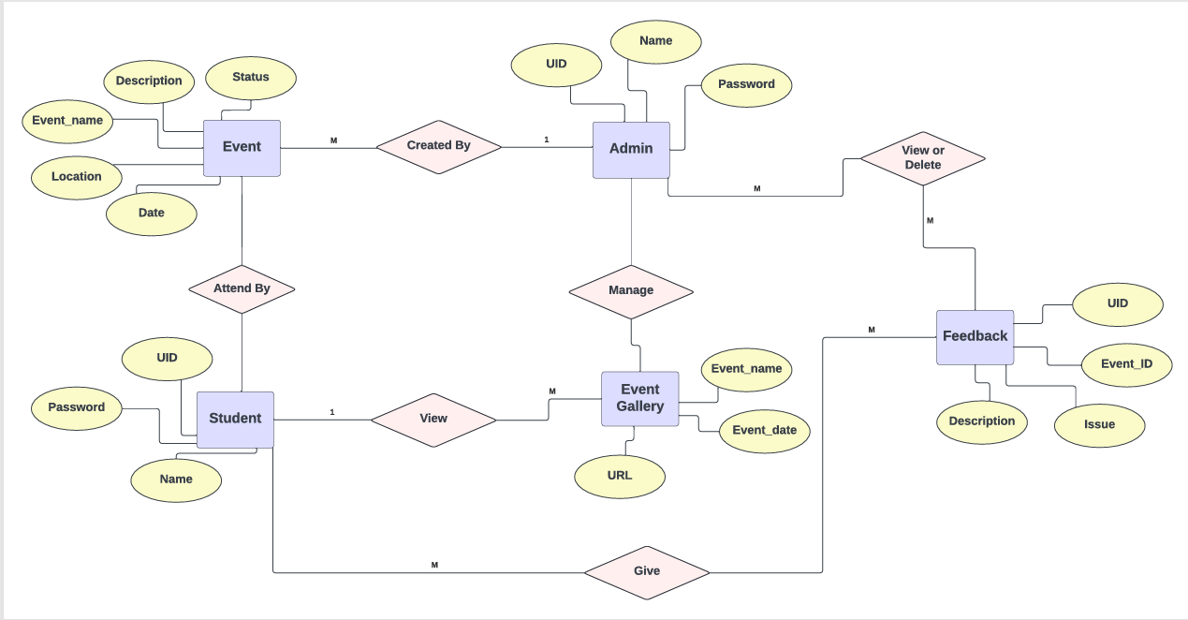

**Chapter 4**

**RESULT ANALYSIS AND VALIDATION**

**Implementation of Solution**

The implementation phase represents the most critical stage of the project lifecycle, as it transforms theoretical design and planning into a working and interactive platform. For *Eventra*, the goal was to build a fully functional, responsive, and visually appealing web-based event management system that streamlines the process of creating, managing, and participating in events. The implementation began with setting up the core development environment, including the integration of HTML, CSS, JavaScript, and PHP for the frontend and backend operations. MySQL was used as the primary database management system due to its efficiency, scalability, and open-source nature.

The implementation followed an incremental development model. Each module, such as the user registration, login authentication, event creation, and participation dashboard, was developed and tested individually before being integrated into the final system. This modular approach ensured that issues could be isolated and resolved efficiently without affecting the overall system functionality. During the implementation phase, special attention was given to security features such as data validation, SQL injection prevention, and session management to maintain the integrity and confidentiality of user data.

The frontend development prioritized a modern, user-friendly interface with a focus on simplicity and intuitive navigation. Bootstrap and custom CSS were used to ensure a responsive design that adapts seamlessly across devices. JavaScript was implemented to handle client-side interactivity, such as live form validation and dynamic content rendering. The backend implementation, managed through PHP and MySQL, handled data retrieval, processing, and storage. PHP scripts were optimized for faster server responses and efficient database queries, ensuring a smooth user experience.

After deployment, the solution was tested on multiple browsers and devices to ensure compatibility and responsiveness. The hosting environment was simulated locally using XAMPP before final deployment, which allowed for real-time debugging and validation of the codebase.

**Front-End Implementation**

**Landing Page**

<!DOCTYPE html>

<html lang="en">

  <head>

    <meta charset="UTF-8" />

    <meta name="viewport" content="width=device-width, initial-scale=1.0" />

    <title>CU Eventra - Chandigarh University Event Management</title>

    <meta name="description" content="Empowering Campus Life Through Events - Chandigarh University's premier event management system"/>

    <meta name="author" content="Rahul Saxena" />

    <link rel="preconnect" href="https://fonts.googleapis.com" />

    <link rel="preconnect" href="https://fonts.gstatic.com" crossorigin />

    <link href="https://fonts.googleapis.com/css2?family=Inter:wght@300;400;500;600;700;800&family=Poppins:wght@300;400;500;600;700;800&display=swap"

      rel="stylesheet"

    />

    <link rel="stylesheet" href=<https://cdnjs.cloudflare.com/ajax/libs/font-awesome/6.5.1/css/all.min.css> />

    <link rel="stylesheet" href="style.css" />

    <meta property="og:title" content="CU Eventra - Chandigarh University Event Management" />

    <meta property="og:description" content="Empowering Campus Life Through Events" />

    <meta property="og:type" content="website" />

    <meta property="og:image" content=<https://lovable.dev/opengraph-image-p98pqg.png> />

    <meta name="twitter:card" content="summary_large_image" />

    <meta name="twitter:site" content="@lovable_dev" />

    <meta name="twitter:image" content="https://lovable.dev/opengraph-image-p98pqg.png"/>

  </head>

  <body>

    <button id="scrollToTopBtn" title="Go to top">

      <i class="fas fa-arrow-up"></i>

    </button>

    <section id="hero" class="hero-section">

      <div class="hero-background">

        <div class="hero-overlay"></div>

      </div>

      <div class="floating-element floating-1"></div>

      <div class="floating-element floating-2"></div>

      <div class="floating-element floating-3"></div>

      <div class="hero-content">

        <div class="hero-text">

          <h1 class="hero-title">

            <span class="title-line">CU</span>

            <span class="title-highlight">Eventra</span>

          </h1>

          <p class="hero-subtitle">Empowering Campus Life Through Events</p>

          <p class="hero-description">

            Discover, register, and experience the vibrant campus culture at

            Chandigarh University. Your gateway to academic excellence and

            unforgettable memories.

          </p>

          <div class="hero-buttons">

            <button class="btn btn-primary">

              <i class="fas fa-calendar-alt"></i>

              Explore Events

            </button>

            <button class="btn btn-secondary">

              <i class="fas fa-user-shield"></i>

              Sign In.

            </button>

          </div>

        </div>

        <div class="scroll-indicator">

          <i class="fas fa-chevron-down"></i>

        </div>

      </div>

    </section>

    <section id="about" class="about-section">

      <div class="background-pattern">

        <div class="pattern-circle pattern-1"></div>

        <div class="pattern-circle pattern-2"></div>

        <div class="pattern-circle pattern-3"></div>

      </div>

      <div class="container">

        <div class="section-header scroll-animate">

          <h2 class="section-title">About CU Eventra</h2>

          <p class="section-subtitle">

            Transforming campus life through seamless event management

          </p>

        </div>

        <div class="about-grid">

          <div class="about-content scroll-animate">

            <h3 class="about-title">Revolutionizing Campus Events</h3>

            <p class="about-text">

              CU Eventra is Chandigarh University's premier event management

              portal, designed to bridge the gap between event organizers and

              students. Our platform streamlines the entire event lifecycle from

              discovery to feedback.

            </p>

            <p class="about-text">

              Whether you're a student looking to enhance your campus experience

              or an administrator managing events, our intuitive system provides

              all the tools you need for success.

            <p>

            <div class="stats-grid">

              <div class="stat-item">

                <div class="stat-number">500+</div>

                <div class="stat-label">Events Managed</div>

              </div>

              <div class="stat-item">

                <div class="stat-number">10K+</div>

                <div class="stat-label">Active Students</div>

              </div>

            </div>

          </div>

          <div class="about-features scroll-animate">

            <div class="card features-card">

              <div class="feature-item">

                <div class="feature-icon">

                  <i class="fas fa-search"></i>

                </div>

                <div class="feature-content">

                  <h4 class="feature-title">Event Discovery</h4>

                  <p class="feature-description">

                    Browse and discover exciting campus events tailored to your

                    interests

                  </p>

                </div>

              </div>

              <div class="feature-item">

                <div class="feature-icon">

                  <i class="fas fa-ticket-alt"></i>

                </div>

                <div class="feature-content">

                  <h4 class="feature-title">Smart Registration</h4>

                  <p class="feature-description">

                    Seamless registration process with automated ticket

                    generation

                  </p>

                </div>

              </div>

              <div class="feature-item">

                <div class="feature-icon">

                  <i class="fas fa-comments"></i>

                </div>

                <div class="feature-content">

                  <h4 class="feature-title">Feedback System</h4>

                  <p class="feature-description">

                    Share experiences and help improve future events

                  </p>

                </div>

              </div>

            </div>

          </div>

        </div>

      </div>

    </section>

</body></html>

**OUTPUT:**

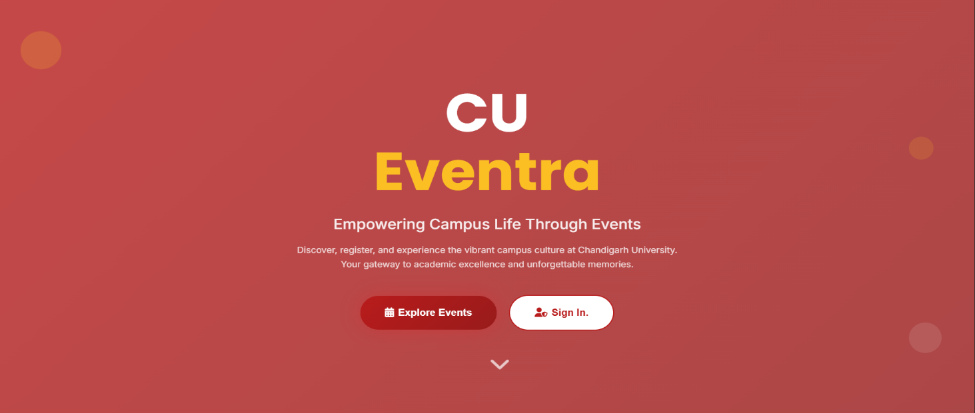

**Login Page**

<?php

session_start();

include "config.php";

$error = "";

if ($_SERVER['REQUEST_METHOD'] == 'POST') {

    $uid = trim($_POST['uid']);

    $password = trim($_POST['password']);

    if (!empty($uid) && !empty($password)) {

        // Check user in DB

        $sql = "SELECT * FROM users WHERE uid = ?";

        $stmt = $conn->prepare($sql);

        $stmt->bind_param("s", $uid);

        $stmt->execute();

        $result = $stmt->get_result();

        if ($result->num_rows === 1) {

          $user = $result->fetch_assoc();

          if ($user['password'] === md5($password)) {

              $_SESSION['uid']  = $user['uid'];

              $_SESSION['name'] = $user['name'];

              $_SESSION['role'] = $user['role'];

              if ($user['role'] === 'admin') {

                  header("Location: admin/dashboard.php");

              } elseif ($user['role'] === 'student') {

                  header("Location: student/dashboard.php");

              } else {

                  $error = "User role not assigned. Please contact admin.";

              }

              exit();

        } else {

            $error = "Invalid password.";

        }

    } else {

      $error = "User not found.";

    }

    } else {

        $error = "Please enter both UID and Password.";

    }

}

?>

<!DOCTYPE html>

<html lang="en">

  <head>

    <meta charset="UTF-8" />

    <meta name="viewport" content="width=device-width, initial-scale=1.0" />

    <title>College Event Management - Login</title>

    <script src="https://cdn.tailwindcss.com"></script>

    <link rel="stylesheet" href="https://use.typekit.net/yjp3aho.css" />

    <link

      rel="stylesheet"

      href="https://cdnjs.cloudflare.com/ajax/libs/font-awesome/6.4.0/css/all.min.css"

    />

    <script>

      tailwind.config = {

        theme: {

          extend: {

            fontFamily: {

              sofia: ["sofia-pro", "sans-serif"],

            },

            colors: {

              "university-blue": "#1e3a8a",

              "university-light": "#3b82f6",},},},};

    </script>

  </head>

  <body class="min-h-screen login-bg font-sofia">

    <div class="min-h-screen flex items-center justify-center px-4 py-8" data-id="main-container">

      <div class="w-full max-w-md fade-in" data-id="login-card">

        <div class="text-center mb-8" data-id="header-section">

          <div class="inline-flex items-center justify-center w-16 h-16 bg-white rounded-full shadow-lg mb-4" data-id="logo-container" >

            <I data-lucide="graduation-cap" class="w-8 h-8 text-university-blue" ></i>

          </div>

          <h1 class="text-3xl font-bold text-white mb-2" data-id="main-title"> College Event Hub </h1>

          <p class="text-blue-100" data-id="subtitle"> Login to manage your events</p>

        </div>

        <div class="form-glass rounded-2xl shadow-2xl p-8" data-id="form-container" >

          <div id="error-display" class="error-message mb-4 hidden" data-id="error-display">

            <div class="bg-red-50 border border-red-200 rounded-lg p-3 flex items-center" data-id="error-content" >

              <I data-lucide="alert-circle" class="w-5 h-5 text-red-500 mr-2" ></i>

              <span class="text-red-700 text-sm" id="error-text" data-id="error-text"> Please check your credentials and try again.</span></div></div>

          <form method="POST" action="login.php" id="loginForm" data-id="login-form" >

            <div class="mb-6" data-id="uid-field-container">

              <label for="uid" class="block text-sm font-medium text-gray-700 mb-2" data-id="uid-label"> University ID

              </label>

              <div class="relative transform-reset" data-id="uid-input-wrapper">

                <div class="absolute inset-y-0 left-0 pl-3 flex items-center pointer-events-none" data-id="uid-icon">

                  <I data-lucide="user" class="w-5 h-5 text-gray-400"></i>

                </div>

                <input type="text" id="uid" name="uid" required class="transform-reset input-focus block w-full pl-10 pr-3 py-3 border border-gray-300 rounded-lg focus:ring-2 focus:ring-university-light focus:border-transparent transition-all duration-200 text-gray-900 placeholder-gray-500" placeholder="Enter your University ID" data-id="uid-input"/></div></div>

            <div class="mb-6" data-id="password-field-container">

              <label for="password" class="block text-sm font-medium text-gray-700 mb-2" data-id="password-label"> Password</label>

              <div class="relative" data-id="password-input-wrapper">

                <div class="absolute inset-y-0 left-0 pl-3 flex items-center pointer-events-none" data-id="password-icon">

                  <i data-lucide="lock" class="w-5 h-5 text-gray-400"></i>

                </div>

                <input type="password" id="password" name="password" required class="transform-reset input-focus block w-full pl-10 pr-12 py-3 border border-gray-300 rounded-lg focus:ring-2 focus:ring-university-light focus:border-transparent transition-all duration-200 text-gray-900 placeholder-gray-500" placeholder="Enter your password" data-id="password-input" />

          </form>

          <div class="mt-8 pt-6 border-t border-gray-200 text-center" data-id="additional-links">

            <p class="text-sm text-gray-600" data-id="signup-prompt">

              Need an account?

              <a href="#" class="text-university-blue hover:text-university-light font-medium transition-colors" data-id="signup-link"

              >

                Contact IT Support

              </a>

            </p>

          </div>

        </div>

        <!-- Footer -->

        <div class="text-center mt-8" data-id="footer-section">

          <p class="text-blue-100 text-sm" data-id="footer-text">

            © 2024 University Event Management System

          </p>

        </div>

      </div>

    </div>

  </body>

</html>

**OUTPUT:**

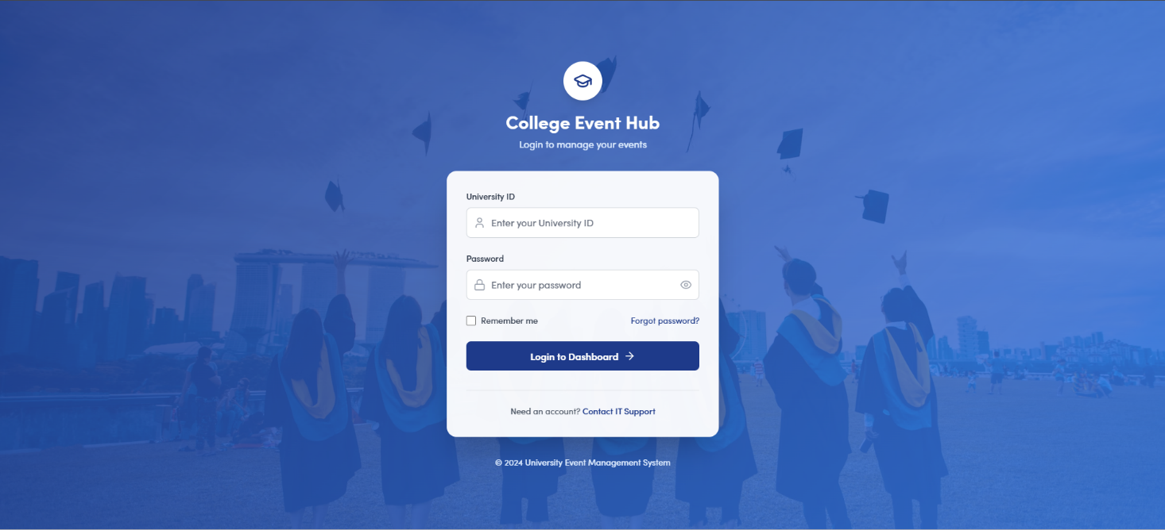

**Student Dashboard**

<?php

session_start();

if (!isset($_SESSION['uid'])) { // Assuming 'uid' is set on login

    header("Location: login.php");

    exit();

}

$student_name = isset($_SESSION['name']) ? $_SESSION['name'] : 'Student';

?>

<!DOCTYPE html>

<html lang="en">

<head>

    <meta charset="UTF-8">

    <meta name="viewport" content="width=device-width, initial-scale=1.0">

    <title>Eventra - Student Dashboard</title>

    <script src="https://cdn.tailwindcss.com"></script>

    <link rel="stylesheet" href="https://use.typekit.net/yjp3aho.css">

    <script src="https://unpkg.com/lucide@latest"></script>

    <link href="https://fonts.googleapis.com/css2?family=Inter:wght@300;400;500;600;700;800&display=swap" rel="stylesheet">

    <script src="https://kit.fontawesome.com/b5b6622958.js" crossorigin="anonymous"></script>

</head>

<body class="bg-gray-50 min-h-screen relative overflow-x-hidden">

    <div class="custom-cursor" data-id="custom-cursor"></div>

    <header data-id="main-header" class="gradient-bg text-white shadow-2xl sticky top-0 z-40 fade-in">

        <div class="container mx-auto px-4">

            <div class="flex justify-between items-center py-4">

                <div data-id="logo-section" class="flex items-center space-x-3">

                    <a href="dashboard.php" class="flex items-center space-x-3">

                        <div class="w-10 h-10 bg-white rounded-lg flex items-center justify-center shadow-md">

                            <i class="fa-regular fa-calendar-check w-6 h-6 text-purple-600" style="font-size: 1.5rem;"></i>

                        </div>

                        <h1 class="text-2xl font-bold">Eventra</h1>

                    </a>

                </div>

                <nav class="hidden md:flex items-center space-x-8 text-sm font-medium">

                    <a href="dashboard.php" class="hover:text-purple-200 transition-colors duration-300">Home</a>

                    <a href="event_gallery.php" class="hover:text-purple-200 transition-colors duration-300">Event Gallery</a>

                    <a href="tickets.php" class="hover:text-purple-200 transition-colors duration-300">Your Tickets</a>

                    <a href="feedback.php" class="hover:text-purple-200 transition-colors duration-300">Feedback Form</a>

                    <a href="logout.php" class="bg-white/20 hover:bg-white/30 px-4 py-2 rounded-lg transition-all duration-300 backdrop-blur-sm">

                        Logout

                    </a>

                </nav>

                <button id="menu-btn" class="md:hidden text-2xl z-50">

                    <i class="fa-solid fa-bars"></i>

                </button>

            </div>

            </div>

        </section>

        <section data-id="events-section" class="mb-16 fade-in fade-in-delay-2">

                <div class="flex items-center justify-between mb-8">

                <h3 data-id="events-title" class="text-3xl font-bold text-gray-800">

                    Campus Events

                </h3>

                <div data-id="events-filter" class="flex space-x-2">

                    <button class="filter-btn active px-4 py-2 rounded-lg bg-blue-600 text-white" data-filter="all">All</button>

                    <button class="filter-btn px-4 py-2 rounded-lg bg-gray-200 text-gray-700 hover:bg-gray-300" data-filter="active">Active</button>

                    <button class="filter-btn px-4 py-2 rounded-lg bg-gray-200 text-gray-700 hover:bg-gray-300" data-filter="upcoming">Upcoming</button>

                    <button class="filter-btn px-4 py-2 rounded-lg bg-gray-200 text-gray-700 hover:bg-gray-300" data-filter="completed">Completed</button>

                </div>

                </div>

                <div data-id="events-grid" class="grid grid-cols-1 md:grid-cols-2 lg:grid-cols-3 gap-8">

                                            <b style='padding-top: 15px;'>{$row['location']}</b>

                                        </div>

                                        <a href='event_register.php?event_id={$row['id']}'

                                           class='mt-3 inline-block px-4 py-2 bg-blue-600 text-white text-sm font-medium rounded-lg hover:bg-blue-700 transition'>

                                           Register Now</a></div>                                </div>";}

                    } else {

                        echo "

                            <div data-id='no-events' class='text-center py-16 col-span-3'>

                                <div class='w-24 h-24 mx-auto mb-6 bg-gray-100 rounded-full flex items-center justify-center'>

                                    <i data-lucide='calendar-x' class='w-12 h-12 text-gray-400'></i>

                                </div>

                                <h4 class='text-xl font-semibold text-gray-600 mb-2'>No Events Available</h4>

                                <p class='text-gray-500'>Check back later for exciting events!</p>

                            </div>

                        ";

                    }

                    $conn->close();

                    ?>

                </div>

        </section>

        <section data-id="why-attend-section" class="mb-16 fade-in fade-in-delay-3">

            <div class="gradient-card rounded-2xl p-8 shadow-xl">

                <h3 data-id="why-attend-title" class="text-3xl font-bold text-gray-800 text-center mb-12">

                    Why Attend Events? 🎉

                </h3>

                <div class="grid grid-cols-1 md:grid-cols-2 lg:grid-cols-4 gap-8">

                    <div data-id="benefit-1" class="text-center float">

                        <div class="w-16 h-16 mx-auto mb-4 bg-gradient-to-r from-blue-500 to-purple-600 rounded-full flex items-center justify-center">

                            <i class="fa-solid fa-users w-8 h-8 text-white" style="font-size: 1.7rem; padding: 4px 4px 5px 0px;"></i>

                        </div>

                        <h4 class="text-lg font-semibold text-gray-800 mb-2">Network & Connect</h4>

                        <p class="text-gray-600">Meet like-minded students and build lasting friendships</p>

                    </div>

                    <div data-id="benefit-2" class="text-center float" style="animation-delay: 0.5s;">

                        <div class="w-16 h-16 mx-auto mb-4 bg-gradient-to-r from-green-500 to-teal-600 rounded-full flex items-center justify-center">

                            <i class="fa-solid fa-brain w-8 h-8 text-white" style="font-size: 1.7rem; padding: 4px 4px 5px 0px;"></i>

                        </div>

                        <h4 class="text-lg font-semibold text-gray-800 mb-2">Learn & Grow</h4>

                        <p class="text-gray-600">Acquire new skills and expand your knowledge base</p>

                    </div>

                    <div data-id="benefit-3" class="text-center float" style="animation-delay: 1s;">

                        <div class="w-16 h-16 mx-auto mb-4 bg-gradient-to-r from-yellow-500 to-orange-600 rounded-full flex items-center justify-center">

                            <i class="fa-solid fa-trophy w-8 h-8 text-white" style="font-size: 1.7rem; padding: 4px 4px 5px 0px;"></i>

                        </div>

                        <h4 class="text-lg font-semibold text-gray-800 mb-2">Win Prizes</h4>

                        <p class="text-gray-600">Participate in competitions and win amazing rewards</p>

                    </div>

                    <div data-id="benefit-4" class="text-center float" style="animation-delay: 1.5s;">

                        <div class="w-16 h-16 mx-auto mb-4 bg-gradient-to-r from-pink-500 to-rose-600 rounded-full flex items-center justify-center">

                            <i class="fa-regular fa-heart w-8 h-8 text-white" style="font-size: 1.7rem; padding: 4px 4px 5px 0px;"></i>

                        </div>

                        <h4 class="text-lg font-semibold text-gray-800 mb-2">Have Fun</h4>

                        <p class="text-gray-600">Enjoy memorable experiences and create lasting memories</p>

                    </div>

                </div>

            </div>

        </section>

    </main>

body></html>

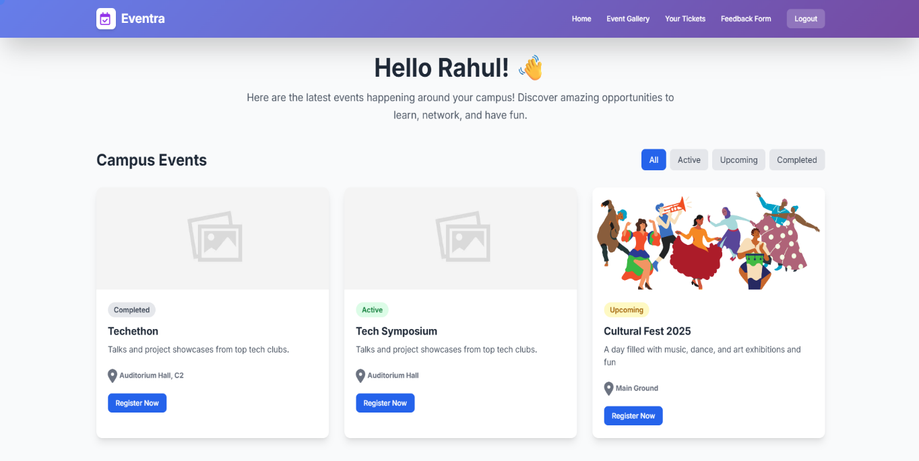

**Admin Dashboard**

<?php

include '../config.php';

session_start();

if (!isset($_SESSION['uid']) || $_SESSION['role'] !== 'admin') {

    header('Location: login.php');

    exit();

}

$name = $_SESSION['name'];

$totalUsers = $conn->query("SELECT COUNT(*) as count FROM users")->fetch_assoc()['count'];

$totalEvents = $conn->query("SELECT COUNT(*) as count FROM events")->fetch_assoc()['count'];

$totalRegistrations = $conn->query("SELECT COUNT(*) as count FROM event_registrations")->fetch_assoc()['count'];

$totalFeedback = $conn->query("SELECT COUNT(*) as count FROM event_feedback")->fetch_assoc()['count'];

$chartLabels = [];

$chartData = [];

$chartSql = "SELECT DATE_FORMAT(created_at, '%Y-%m') as month, COUNT(id) as count

             FROM events

             GROUP BY month

             ORDER BY month ASC

             LIMIT 6";

$chartResult = $conn->query($chartSql);

while ($row = $chartResult->fetch_assoc()) {

    $chartLabels[] = date("M Y", strtotime($row['month'] . "-01"));

    $chartData[] = $row['count'];

}

$recentFeedback = [];

$feedbackSql = "SELECT ef.issue, e.event_name, ef.submitted_at

                FROM event_feedback ef

                JOIN events e ON ef.event_id = e.id

                ORDER BY ef.submitted_at DESC

                LIMIT 5";

$feedbackResult = $conn->query($feedbackSql);

while($row = $feedbackResult->fetch_assoc()) {

    $recentFeedback[] = $row;

}

?>

<!DOCTYPE html>

<html lang="en">

<head>

    <meta charset="UTF-8">

    <title>Admin Dashboard - Eventra</title>

    <link href="https://cdn.jsdelivr.net/npm/bootstrap@5.3.3/dist/css/bootstrap.min.css" rel="stylesheet">

    <link rel="preconnect" href="https://fonts.googleapis.com">

    <link rel="preconnect" href="https://fonts.gstatic.com" crossorigin>

</head>

<body>

    <div class="sidebar">

        <div class="sidebar-header">

            <h2><i class="fa-solid fa-shield-halved"></i> Eventra</h2>

        </div>

        <nav class="sidebar-nav">

            <a href="dashboard.php" class="active"><i class="fa-solid fa-house"></i> Dashboard</a>

            <a href="manage_users.php"><i class="fa-solid fa-users"></i> Manage Users</a>

            <a href="manage_events.php"><i class="fa-solid fa-calendar-days"></i> Manage Events</a>

            <a href="manage_gallery.php"><i class="fa-solid fa-image"></i> Event Gallery</a>

            <a href="manage_feedback.php"><i class="fa-solid fa-comments"></i> Feedback</a>

        </nav>

        <div class="sidebar-footer">

            <a href="../logout.php"><i class="fa-solid fa-right-from-bracket"></i> Logout</a>

        </div>

    </div>

    <main class="main-content">

        <header class="dashboard-header">

            <div>

                <h1 class="h3 mb-0">Admin Dashboard</h1>

                <p class="mb-0 text-muted">Welcome back, <?= htmlspecialchars($name) ?> 👋</p>

            </div>

            <a href="manage_events.php" class="btn btn-primary"><i class="fa-solid fa-plus me-2"></i>Create Event</a>

        </header>

        <div class="row g-4 mb-4">

            <div class="col-md-6 col-xl-3">

                <div class="stat-card">

                    <div class="icon bg-primary"><i class="fa-solid fa-users"></i></div>

                    <div>

                        <h3 class="mb-0 fw-bold"><?= $totalUsers ?></h3>

                        <p class="mb-0 text-muted">Total Users</p>

                    </div>

                </div>

            </div>

            <div class="col-md-6 col-xl-3">

                <div class="stat-card">

                    <div class="icon bg-success"><i class="fa-solid fa-calendar-check"></i></div>

                    <div>

                        <h3 class="mb-0 fw-bold"><?= $totalEvents ?></h3>

                        <p class="mb-0 text-muted">Total Events</p>

                    </div>

                </div>

            </div>

            <div class="col-md-6 col-xl-3">

                <div class="stat-card">

                    <div class="icon bg-warning"><i class="fa-solid fa-ticket"></i></div>

                    <div>

                        <h3 class="mb-0 fw-bold"><?= $totalRegistrations ?></h3>

                        <p class="mb-0 text-muted">Registrations</p>

                    </div>

                </div>

            </div>

            <div class="col-md-6 col-xl-3">

                <div class="stat-card">

                    <div class="icon bg-danger"><i class="fa-solid fa-comments"></i></div>

                    <div>

                        <h3 class="mb-0 fw-bold"><?= $totalFeedback ?></h3>

                        <p class="mb-0 text-muted">Feedback</p>

                    </div>

                </div>

            </div>

        </div>

        <div class="row g-4">

            <div class="col-lg-7">

                <div class="chart-container">

                    <h5 class="mb-3">Event Creation Trends</h5>

                    <div style="position: relative; height: 350px;">

                        <canvas id="eventChart"></canvas>

                    </div>

                </div>

            </div>

            <div class="col-lg-5">

                <div class="recent-activity">

                    <h5 class="mb-3">Recent Feedback</h5>

                    <ul class="list-group list-group-flush">

                        <?php if(!empty($recentFeedback)): ?>

                            <?php foreach($recentFeedback as $feedback): ?>

                                <li class="list-group-item d-flex justify-content-between align-items-center px-0">

                                    <div>

                                        <h6 class="mb-0"><?= htmlspecialchars($feedback['issue']) ?></h6>

                                        <small class="text-muted">for <?= htmlspecialchars($feedback['event_name']) ?></small>

                                    </div>

                                    <small class="text-muted"><?= date('M d', strtotime($feedback['submitted_at'])) ?></small>

                                </li>

                            <?php endforeach; ?>

                        <?php else: ?>

                            <li class="list-group-item px-0 text-muted">No feedback submitted yet.</li>

                        <?php endif; ?>

                    </ul>

                </div>

            </div>

        </div>

    </main></body></html>

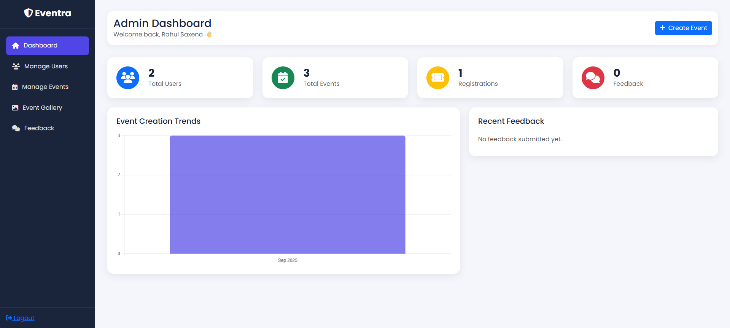

**Login Page Redirection**

<?php

session_start();

include "config.php";

$error = "";

if ($_SERVER['REQUEST_METHOD'] == 'POST') {

    $uid = trim($_POST['uid']);

    $password = trim($_POST['password']);

    if (!empty($uid) && !empty($password)) {

        // Check user in DB

        $sql = "SELECT * FROM users WHERE uid = ?";

        $stmt = $conn->prepare($sql);

        $stmt->bind_param("s", $uid);

        $stmt->execute();

        $result = $stmt->get_result();

        if ($result->num_rows === 1) {

          $user = $result->fetch_assoc();

          if ($user['password'] === md5($password)) {

              $_SESSION['uid']  = $user['uid'];

              $_SESSION['name'] = $user['name'];

              $_SESSION['role'] = $user['role'];

              if ($user['role'] === 'admin') {

                  header("Location: admin/dashboard.php");

              } elseif ($user['role'] === 'student') {

                  header("Location: student/dashboard.php");

              } else {

                  $error = "User role not assigned. Please contact admin.";

              }

              exit();

        } else {

            $error = "Invalid password.";

        }

    } else {

      $error = "User not found.";

    }

    } else {

        $error = "Please enter both UID and Password.";

    }

}

?>

**Database Connection [config.php]**

<?php

// Database Connection

$host = "localhost";

$user = "root";

$pass = "12345";

$db   = "college_event_system";

$conn = new mysqli($host, $user, $pass, $db, 3306);

if ($conn->connect_error) {

    die("Database Connection Failed: " . $conn->connect_error);

}

?>

**Authentication Check**

<?php

session_start();

if (!isset($_SESSION['user_id'])) {

    header("Location: ../login.php");

    exit();

}

?>

**Report Preparation**

The preparation of the project report was carried out in parallel with the development phase, ensuring that all aspects of the system were well-documented. The report serves as both a technical reference and a reflective analysis of the entire development journey. Each chapter was carefully structured to align with the project’s objectives and demonstrate the progression from problem identification to final validation.

Comprehensive documentation was maintained throughout, including flowcharts, design diagrams, code structure, and user interface screenshots. These inclusions helped establish clarity in explaining how the system works internally and how each module interacts with others. The report preparation also involved an iterative review process, where sections were continuously refined for clarity, technical depth, and originality. This ensured that the documentation accurately represented the project’s objectives, challenges, and outcomes without any form of plagiarism.

Special attention was also given to formatting and academic integrity. The report follows a formal structure with citations and references wherever external ideas or technologies were discussed. The preparation phase concluded with the compilation of appendices, including the system’s code snippets, test case results, and feedback summaries.

**Project Management and Communication**

Effective project management was one of the major contributors to the success of *Eventra*. The entire project was divided into phases — planning, design, implementation, testing, and deployment. Each phase had specific deliverables and timelines to ensure that progress remained on track. Tools such as Trello and Google Sheets were used to track daily activities, deadlines, and milestones, providing clear visibility into the project’s advancement.

Regular communication played a pivotal role throughout the development. Weekly meetings were scheduled (self-reviewed or team-based, depending on project scope) to evaluate the progress, discuss challenges, and propose possible solutions. Collaborative communication ensured that all ideas were thoroughly vetted before implementation, minimizing rework and errors.

Additionally, agile methodologies were adopted for flexibility. The iterative approach allowed modifications based on feedback, ensuring that the system continuously evolved to meet the end goals. Stakeholder communication, where applicable, involved presenting prototypes and collecting feedback to refine the user experience and design layout. The project management and communication strategy together ensured timely completion, minimal development bottlenecks, and a product aligned with its original vision.

**Testing, Interpretation, and Data Validation**

Testing and validation formed the final and most crucial stage before concluding the development cycle. It ensured that the *Eventra* system was reliable, secure, and functionally complete. The testing process was divided into several categories — unit testing, integration testing, system testing, and user acceptance testing (UAT).

**Unit** **Testing:**

Each component of the system, such as login authentication, event creation form, and participant dashboard, was individually tested for logical errors and boundary conditions. Test data were created to validate the system’s handling of valid and invalid inputs. For instance, attempts to log in with incorrect credentials were tested to ensure that proper error messages appeared without disclosing sensitive information.

**Integration Testing:**

After confirming the functionality of individual modules, integration testing was performed to verify that combined modules interacted seamlessly. For example, data entered during event creation had to appear accurately in the participant’s dashboard and in the administrative control panel. The communication between frontend forms and backend scripts was monitored to ensure consistency and data accuracy.

**System Testing:**

System testing was conducted in a simulated environment to mimic real-world user conditions. The entire workflow, from registration to event participation, was tested to ensure a smooth and error-free experience. Browser compatibility tests were carried out across Chrome, Firefox, and Edge, and the system was validated on multiple screen sizes to confirm responsiveness.

**User Acceptance Testing (UAT):**

Finally, user acceptance testing was performed with a small group of testers who evaluated the usability, design appeal, and functionality of *Eventra*. Their feedback was used to make final refinements before deployment. This phase validated that the solution met all intended objectives and provided a satisfactory user experience.

**Data Validation:**

Ensuring the integrity and accuracy of stored data was another essential aspect of testing. Validation mechanisms were implemented both at the frontend (through form validation using JavaScript) and backend (using PHP validation functions and SQL constraints). Cross-verification was done to ensure that all user inputs adhered to defined formats and that database entries were consistent. SQL queries were optimized to prevent injection vulnerabilities, and session management was tested to confirm that unauthorized access was not possible.

After all testing phases, performance metrics such as load time, response time, and database retrieval speed were analysed. The final results demonstrated that *Eventra* operates efficiently under normal load conditions and can handle multiple concurrent users without performance degradation.

**Chapter 5**

**CONCLUSION & FUTURE WORK**

**Conclusion**

The development of Eventra marks the successful culmination of an extensive process of research, design, implementation, and rigorous validation. This project was conceived to solve a tangible, real-world problem deeply rooted in the college environment: the chronic fragmentation of event communication. In today’s fast-paced digital world, the reliance on manual or disparate systems for event management inevitably leads to confusion, inefficiency, and a significant waste of time and resources. This project has successfully confronted these challenges by architecting and delivering an integrated, web-based platform that fundamentally simplifies event creation, registration, communication, and participation. Through the strategic application of modern, robust web technologies—including HTML for structure, CSS for responsive design, JavaScript for client-side interactivity, PHP for powerful server-side logic, and MySQL for reliable data management—Eventra provides an organized, user-friendly, and dynamic ecosystem for all campus happenings.

The system was conceptualized with a clear vision: to bring automation, convenience, and a sense of community to the often-chaotic world of event coordination. Throughout the project's lifecycle, several critical design and technical objectives were established, including ensuring intuitive ease of use, building for scalability, and guaranteeing system reliability. These objectives were methodically achieved through a careful analysis of user requirements, an efficient and normalized database design, and the seamless integration of robust validation and testing mechanisms. Each component of the system was meticulously planned and executed. The secure user authentication module protects student data, the administrative back-end empowers the event team, the dynamic student dashboard serves as an information hub, and the automated E-ticket system professionalizes event entry.

The comprehensive testing and validation phases confirmed that Eventra performs efficiently and consistently across different web browsers and devices, validating its cross-platform compatibility and responsive design. The user interface was consistently found to be intuitive and accessible, requiring minimal technical expertise from its users. Crucially, foundational security measures, including server-side input sanitization to prevent XSS attacks and password hashing to protect user credentials, were implemented to safeguard user data and maintain the integrity of the entire system.

The project management strategies and diligent report preparation adopted throughout the development cycle were instrumental in maintaining workflow discipline and project coherence. This structured approach ensured that the development process remained firmly aligned with the initially identified problem statement and the expectations of the end-users. The completion of Eventra stands as a testament to the successful application of academic knowledge, practical technical skills, and systematic project planning.

Ultimately, Eventra not only fulfilled its intended objectives but also created a powerful foundation for future exploration and advancement in event management technology. It serves as a compelling case study of how web technologies can be leveraged to address real-life coordination and communication challenges, effectively bridging the informational gap between event organizers and the student community. In conclusion, Eventra is a fully functional, scalable, and innovative platform that contributes meaningfully to the ongoing digital transformation in management systems, poised to enhance the very fabric of the campus experience.

**Future Work and Scope for Enhancement**

While the current implementation of Eventra successfully achieves its core objectives, its foundational architecture is designed for growth. The future scope of this project is vast, with numerous avenues for integrating advanced technologies and functionalities that can transform it from a management tool into an intelligent campus ecosystem.

* Integration of Artificial Intelligence (AI) and Machine Learning (ML): The next logical evolution for Eventra is to incorporate intelligence. An AI-powered recommendation engine could analyze a student's past event attendance and major to proactively suggest relevant new events. For instance, it could recommend a guest lecture on machine learning to a computer science student who previously attended a hackathon. ML algorithms could also be employed to provide organizers with predictive analytics, forecasting event attendance based on historical data, time of day, and event category, thus enabling better resource planning.
* Dedicated Mobile Application Development (iOS & Android): To maximize accessibility and user engagement, developing a native mobile application is paramount. A mobile app would offer features not possible on a web platform, such as push notifications for real-time updates—notifying students instantly about last-minute venue changes, cancellations, or reminders for events they are registered for. This would significantly enhance convenience and ensure timely communication.
* Secure Payment Gateway Integration: To support larger, more formal events such as paid workshops, concerts, or college festivals, integrating a secure payment gateway (e.g., Razorpay, Stripe) is essential. This would allow organizers to manage ticket sales directly through Eventra, automating financial transactions and providing a comprehensive, end-to-end solution for both free and paid events.
* Advanced Analytics and Reporting Dashboard: Future versions can include a sophisticated data visualization dashboard for event organizers. This module would provide insightful analytics on attendance rates, user demographics (e.g., participation by year or major), peak registration times, and event feedback summaries. These data-driven insights would empower organizers to make informed decisions to optimize future events for maximum impact.
* Cloud Deployment and Enhanced Scalability: Migrating Eventra from a local or college server to a robust cloud platform like Amazon Web Services (AWS) or Google Cloud would offer immense benefits. Cloud hosting would provide superior scalability to handle high traffic during peak times (like the start of a semester or a major festival), ensure higher availability with minimal downtime, and leverage advanced cloud security features.
* Integration with Third-Party Platforms: To embed Eventra into the daily workflow of students, API integrations with external platforms are crucial. An integration with Google Calendar or Microsoft Outlook could allow students to add an event to their personal calendar with a single click. For online or hybrid events, an integration with platforms like Zoom or Google Meet could automatically generate and share meeting links upon registration.
* Comprehensive Feedback and Rating System: Introducing a user-centric feedback mechanism would create a continuous improvement loop. After an event concludes, attendees could be prompted to leave a rating and qualitative feedback. This would not only help organizers understand their audience's experience but also promote a culture of transparency and quality, as event ratings could be publicly visible.
* AI-Powered Chatbot Integration: To enhance user support and engagement, a conversational AI chatbot could be integrated into the platform. This chatbot could provide instant answers to frequently asked questions (e.g., "Where is the seminar hall?"), offer personalized event recommendations based on user queries, and guide new users through the platform's features, significantly improving the overall user experience.

**Reference**

* Ian Sommerville, *Software Engineering*, 9th Edition, Addison-Wesley, 2011.
* Silberschatz, Korth, Sudarshan, *Database System Concepts*, 6th Edition, McGraw Hill, 2011.
* W3Schools – https://www.w3schools.com (for web development tutorials).
* PHP Official Documentation – <https://www.php.net/docs.php>
* MySQL Documentation – https://dev.mysql.com/doc/
* Stack Overflow – <https://stackoverflow.com> (for troubleshooting and coding references).